Annex D: Selected Standing Operating Procedures

Visitor Services SOPs:
• SOP #1: Issuing and Care of Two Way Radio Batteries, 12 MAR 96. Not included.
• SOP #2: Trouble Shooting Problems: Survey Lodge Plumbing Pumps, 10 FEB 96. Not included.
• SOP #3: Lost and Found Procedures, 25 JAN96. PageD-2 thru D-6.
• SOP #4: Emergency Closure All Areas/Sites: Bomb Threat, 15 OCT 95. Under revision. Page D-7 thru D-8.
• SOP #5: Dealing with Media: All Sites, National Mall, 10 OCT 95. Page D-9 thru D-12.
• SOP #6: Dealing with School Groups at Sites, 5 NOV 95. Page D-13 thru D-14.
• SOP #7: Mid-Shift Procedures, 20 NOV 97. Not included.
• SOP #8: Standards for Lead Rangers, 20 NOV 97. Not included.
• SOP #9: Travelers' Information Station, 20 NOV 97. Not included.

Lincoln Memorial SOPs:
• SOP #1-L: Opening/Closing Procedures, 12 MAR 96. Page D-15 thru D-17.
• SOP #2-L: Reactivating Elevator after and Elevator Shutdown, 9 OCT 95. Page D-18.
• SOP #4-L: Emergency Evacuation and Closure, 2001. Pages D-19 to D-20.

Jefferson Memorial SOPs:
• SOP #1-J: Opening/Closing Procedures, 9 OCT 95. Page D-21 thru D-22.
• SOP #2-J: Reactivating Elevator after an Elevator Shutdown, 9 OCT 95. Page D- 23.
• SOP #4-J: Emergency Evacuation and Closure, 2001. Pages D-24 to D-25.

Washington Monument SOPs:
• SOP #l-W: Emergency Elevator Procedures, 15 AUG 95. Page D-26 thru D-28.
• SOP #2-W: Emergency Closure for Lightning Storms, 20 SEP 95. Page D-29 thru D-30.
• SOP #3-W: Emergency Closure for High Winds, 20 SEP 95. Page D-31 thru D-32.
• SOP #4-W: Last Group Procedures, 20 SEP 95. Page D-33.
• SOP #4-W: Emergency Evacuation and Closure, 2001. Pages D-34 to D-36.

Vietnam Veterans Memorial SOPs:
• SOP #1-VVM: Opening/Closing Procedures, 12 MAR 96. Page D-37 thru D-38.
• SOP #2-VVM: Artifact Collection, 12 MAR 96. Not included.
• SOP #3-VVM: Processing Procedures, VVM Artifact Collection, 12 MAR 96. Not included.
• SOP# 4-VVM: Cleaning the VVM Wall, 12 MAR 96. Page D-39.
• SOP# 5-VVM: Procedures for Dealing with Media, 28 OCT 95. Not included.

Korean War Veterans Memorial SOPS:
• SOP #1-K: Procedures for Dealing with Media, 28 OCT 95. Not included.

Franklin Delano Roosevelt Memorial SOPS:
• Memorandum of Do's and Don't's at FDR. Page D-40.

NCP Central SOPs:
• NACC SOP 1-C: SOP During Heat Conditions (not dated). D-41 thru D-42.
STANDARD OPERATING PROCEDURE #3 LOST AND FOUND PROCEDURES
The National Mall
Visitor Services

Approved: (signed E. Broadbent) Site Manager

Date: 10/18/98

As a service to the visitors of the National Park Service, a Lost and Found System has been in effect for many years. To comply with this policy the Administrative Clerk at the National Mall has been assigned the control of the Lost and Found Service for the National Mall. The primary receiving station is Survey Lodge. The procedure for care and disposal of lost and found items is outlined below. Form 10-166 will no longer be used.

Procedure

Found Items

Ranger Responsibilities

- Document contents in log book.

- Items of value (i.e. wallets, cameras, cell phones, pagers, jewelry) should be turned over to U.S. Park Police (USPP) Officer. Do not try to contact the owner, it will be the responsibility of the lost and found station. Call USPP District 1 at 202-619-7310 to have an officer retrieve the items. Document the officers name, badge # and the time you turned the items over in the log book. If an officer is unable to pick up or refuses item(s), document this in the on-site log book and follow step b.

- Items of lesser value (i.e. disposable cameras, sun and eye glasses, clothing, or keys) will be turned in at end of the shift to the Administrative Clerk or Supervisory Park Ranger if the Clerk is not available. Document on the Lost and Found clipboard at Survey Lodge, date, item(s), where it was found and your name.

*DO NOT keep lost and found items at the memorials.

*Items turned into the Survey Lodge Lost and Found will be kept for 7 days, then they will be turned in to U.S. Park Police. Items of no value will be discarded after 7 days.
STANDARD OPERATING PROCEDURE #3 LOST AND FOUND PROCEDURES
(Continued)

Administrative Clerk Responsibilities

- Assign a record number to the found item. The first set of digits indicates fiscal year. The second set of digits indicates month. The third set indicates the number of item found that month. Please fill out the Survey Lodge Lost and Found Record Log as follows:

Record Number L/F Date Description Location USPP Date

99-10-01 F 10/12 keys VVM 10/20
99-10-02 F 10/14 eyeglasses WAMO 10/21

- Document found items on Survey Lodge Lost and Found Report. Turn in all found items to USPP that have been in Survey Lost and Found for 7 days.

Lost Items

Ranger Responsibilities

- Items of value: the owner of the lost item should call the U.S. Park Police District 1 at 202-426-6710.

2. Items of lesser value: call Survey Lodge at 202-426-6841.

Administrative Clerk Responsibilities

- Items of lesser value: a lost report will be filled out by the Administrative Clerk or Supervisory Park Ranger if the Clerk is not available. Survey Lodge Lost and Found Report will be used to report all lost and found items. A copy of the report will be mailed to the owner of the lost item. Please fill out the Lost and Found Record log as follows:

Record Number L/F Date Description Location USPP Date
99-10-03 L 10/10 Glasses KWVM N/A
99-10-04 L 10/10 Keys Lincoln N/A

All calls regarding lost items of value (i.e. wallets, cameras, cell phones or pagers), should be reported lost to USPP, being that found items of value are given to USPP immediately (202-619-7310).
Survey Lodge Lost and Found Daily Log
(Attachment to SOP #3)

L/F | Today's Date | Description | Location L/F | Ranger
Survey Lodge Lost and Found Record Log
(Attachment to SOP #3)

Record Number | L/F | Today's Date | Description | Location L/F | USPP Date

Survey Lodge Lost and Found Report
(Attachment to SOP # 3)

Record Number___________________

Lost___ Found____

Description of Item:

Where item was lost or found:

Employee who turned it in:

Date it was turned into U.S. Park Police:
Contact with owner: Date: Address:
Phone # Home:
Phone # Work:

Date item was returned to owner:

Employee Signature_______________________________ Date______________________

STANDARD OPERATING PROCEDURE #4 EMERGENCY CLOSURE
ALL AREAS/SITES
BOMB THREAT

The National Mall
Visitor Services

Approved: (Signed, E. Broadbent) Site Manager

Date: 10/15/95

If a bomb threat is called into any of the National Mall sites, the following procedures will be adhered to:

1) All two way portable radios, being used at the site, will immediately be turned off.

2) Ranger receiving phone call will follow the attached checklist (See Attached).

3) United States Park Police will be notified and informed of the threat by calling
619-7310.

4) A PHONE CALL will then be placed to the Shift Supervisor at the National Mall's Office 426-6841, and informed of the situation.

5) Shift Supervisor will then proceed to the site and take charge of the area. The Supervisor may close the site down and await the arrival of the Park Police who will then take charge of the site.

6) When closing a site down all visitors, in and around the site, will be informed of the closing and advised to "please leave the site." This will be done in a cool and calm manner. The problem will not be discussed with the visitors and the only answer that should be given to questions is, "we have a problem that has to be dealt with.

7) Shift Supervisor along with the rest of the site staff will take direction from the Park Police and assist with crowd control until the site has been cleared to reopen.

8) Ranger that received the bomb threat will keep his/her self available to be
interviewed by the Park Police and will not discuss the call with other personnel.
STANDARD OPERATING PROCEDURE #4 EMERGENCY CLOSURE ALL
AREAS/SITES BOMB THREAT
(CONTINUED)

BOMB DATA CARD

PLACE THIS CARD UNDER YOUR TELEPHONE

QUESTIONS TO ASK THE CALLER:

1) When is bomb going to explode?

- How many bombs are there?

- Where is it right now?

- What does it look like?

- What kind of bomb is it?

- What will cause it to explode?

- Did you place the bomb?

Why?

What is your name?

EXACT WORDING OF THE THREAT:_______________________________________________________________________________________________________________________________________________________________________________________________________________

Sex of Caller:________Race:____________

Length of call:________________________

PHONE # received____________________

Date:_______________________________
Caller’s Voice:

______Calm ______Nasal
______Angry ______Stutter
______Excited ______Lisp
______Slow ______Raspy
______Rapid ______Deep
______Soft ______Ragged
______Loud ______Clearing Throat
______Laughing _____Deep Breathing
______Crying ______Cracking voice
______Normal ______Disguised
______Distinct ______Accent
______Slurred ______Familiar
______Whispered

If voice is familiar, who did it sound like?________________________________

Background Sounds:
_____Street noises _____Factory machinery
_____Crockery _____Animal noises
_____Voices _____Clear
_____PA System _____Static
_____Household _____Long distance
_____Music _____Local
_____Motor
_____Other:_________________________________
Threat Language:
_____Well spoken _____Incoherent
_____Foul _____Taped
_____Irrational _____Message read

Remarks:____________________________________________________________________________________________________

Report call immediately to USPP at__________________________________

Phone Number:______________________
Date:____________
Name of person who received call:

STANDARD OPERATING PROCEDURE #5 MEDIA CONTACTS
ALL SITES /NAT. MALL

The National Mall
Visitor Services

Approved: (Original Signed) Site Manager

Date: 10/20/98

Staff at the National Mall are responsible for working with a variety of media organizations in diverse circumstances. Permits are issued regularly to the media for all types of filming; b-roll, movies, documentaries, stand-up interviews, and event coverage. While working with the media to achieve their goal, we must assure that the general public is not deterred from visiting and that the resources are not compromised. This SOP provides a standard means of working with the media at the National Mall.

GUIDELINES

The National Park Service (NPS) allows photography and filming within the National
Park System consistent with the protection and public enjoyment of resources. The
NPS will manage these activities according to the following principles and guidelines:

In restricted areas as defined by the Code of Federal Regulations, 36 CFR 7.96 and as defined by the Superintendent in the Park Compendium, only hand-held and B-roll will be allowed.

Cultural, natural, recreational, and wilderness resources will be protected from damage and destruction.

Filming will not unduly conflict with the public's normal use and enjoyment of an area.

Coverage of breaking news never requires a permit, but it is subject to imposition of restrictions and conditions necessary to protect park resources, public health and safety, and park values.

NPS will not censor the content of any filming/photography done in accordance with these principles, nor require finished film products for review, files, or documentation purposes.

Generally permits are NOT required for:

News crews or sound technicians, at news/breaking events.
Commercial or non-commercial groups of 5 or fewer people, using hand-held equipment including tripods and interchangeable lenses, and working during normal visitor use hours in areas that are open to the public. * Wedding photos do not generally require a permit, but they must be done outside the restricted areas.

Definitions:

Breaking-news is an event that cannot be covered at any other time or location. Coverage of breaking news never requires a permit, but is subjected to restrictions and conditions necessary to protect park resources and public health and safety.

Feature news or Event coverage is pre-arranged or planned news programs or stories. Such activities may require a permit, depending on the scope of the coverage.

B-roll is filming using a hand-held camera. On air "talent" is not allowed to speak on b-roll. No permit is required.

Stand-up interviews involve on air talent speaking with another person. Not allowed in restricted areas. * At VVM interviews must be done in Area 5 (East Knoll); we do allow interviews as close as the east walkway as long as they are done behind the fence

A permit is required if the Superintendent determines that there is a likelihood of the project's harming the park's natural, cultural, or recreational resources, or creating unacceptable health or safety risks, or disrupting visitor use and enjoyment. All projects will be thoroughly reviewed not only to ensure protection of the park's resources and values, but also to prevent adverse impact on neighboring communities and non-park interests. The evaluation will consider pedestrian and vehicle traffic, availability of visitor parking, the permittee's needs for vehicles and equipment, and other potential project-related impacts. Safety issues must be identified and resolved.

MEDIA ARRIVAL AND SET-UP:

1. All media are requested to sign in the media log book at the site at which they are filming. Information to be included is organization or company name, producer, on site representative, telephone number, and address.

- Media will be asked to familiarize themselves with restricted and limited use areas and what can and can not be done in those areas. (See attached maps and regulations.)

PARKING

Unless specifically allowed by the permit, the parking of private vehicles (POV) will be in public parking areas only, not in areas around the monuments and memorials. This is for resource protection and visitor safety.

Media and permittees under special events permits may be permitted to park essential vehicles in some areas as long as they do not cause damage to any resource, interfere with the vista, visitor traffic, movement of park equipment, or Tourmobile. For example 1 micro-wave truck and 1 staff car can be parked inside the Lincoln circle at either the north or south ends near the east or west curb.

Arrangements must be made in advance to park POVs or "essential" vehicles in a suitable location.

Lincoln Memorial

B-roll only in the chamber. Interviews are not allowed within the chamber or on the white marble steps. These activities have the potential to create unsafe conditions, impede visitor flow, or disturb the reflective and contemplative nature of the memorial. Tripods may be used but must not impede visitor flow or be placed where they pose a potential safety hazard. Tripods must have rubber tips.

Interviews may be conducted below the white marble steps.

Vietnam Veterans Memorial

Filming and interviews may be conducted on the walkways outside the hatched areas as shown on the accompanying map. * We do allow interviews/stand-up to be done just to the east of the fence along the east walkway in Area 5. Tripods may not be set up or interviews conducted on the memorial walkway, the Three Servicemen Statue and flagpole, and Women's Memorial. These activities have the potential to create unsafe conditions, to impede visitor flow, and be disturbing to the reflective and contemplative nature of the memorial.

In order to accommodate the media and their need to access the memorial, b-roll will be allowed in the grassy bowl area and along the memorial walkways. The east knoll area may be used for stand-up interviews and tripod shots.

Korean War Veterans Memorial

Filming and interviews may be conducted on the walkways outside the hatched areas on the accompanying map. Tripods may not be set up or interviews conducted on the memorial walkways, at the apex near the flag, or around the pool. These activities have the potential to create unsafe conditions, to impede visitor flow, and to be disturbing to the reflective and contemplative nature of the memorial.

To accommodate the media and their need to access the memorial, b-roll will be allowed in the general visitor areas. The grassy area west of the visitor walkway (walkway behind the statues) is designated for stand-up interview and tripod shots.

Parking For The Three Sites:

Unless specifically allowed by the permit, parking is not allowed in areas around the monuments and memorials. Generally permitted vehicles will be allowed to park on the north or south inner curb of the Lincoln Memorial Circle. No vehicles are allowed to park in the vista. Media satellite trucks and microwave trucks may be allowed to park inside the north barricades. * Alwavs read the permits to determine what has been approved.

Washington Monument

Filming and interviews may be conducted on the walkways outside the hatched area on the accompanying map. Tripods may not be set up or interviews conducted on the sidewalk around the monument, in front of the entrance to the monument, or on the interior staircase. These activities have the potential to create unsafe conditions and to impede visitor flow. B-roll only may be conducted at the 500 and 490 foot levels, and on the interior staircase of the monument.

No POVs are allowed at the base of the monument. Parking for microwave trucks is on the south side of the monument. POVs may be parked in the 16th street parking area.

Jefferson Memorial

Filming and interviews may be conducted on the walkways outside the hatched areas on the accompanying map and as shown in Code of Federal Regulations 36, 7.96. B-roll is allowed in the restricted areas. Tripods may be used only with rubber tips and they must not impede visitor flow or enjoyment and must not pose a potential safety hazard.

Parking for essential vehicles is on the west or east side drives. No vehicles are allowed on the plaza. POVs may be parked in the Jefferson Memorial parking lot.
Franklin Delano Roosevelt Memorial

Filming and interviews may be conducted on the walkways outside the hatched areas on the accompanying map. Interviews may not be conducted in the memorial. These activities have the potential to create unsafe conditions, to impede visitor flow, and to be disturbing to the reflective and contemplative nature of the memorial. B-roll is allowed in all areas open to the public. Tripods may be used in the memorial but must have rubber tips and may not impede visitor flow or enjoyment and must not pose a potential safety hazard.

Interviews may be conducted in the grassy areas between the memorial and the tidal basin or outside the entrances to the memorial.

POVs may park along the left side of West basin Drive in the areas posted for parking.

(Maps omitted from this electronic copy…see Part 1 of Guidebook for Restricted Area maps.)
STANDARD OPERATING PROCEDURE #6 DEALING WITH SCHOOL
GROUPS AT THE SITES

The National Mall
Visitor services

Approved: Original Signed (Site Manager)

Date: 11/5/95

When spring arrives on the National Mall, so do the legions of large school groups. Unfortunately, the groups are not always well disciplined or kept under control by their chaperons. These groups can be extremely noisy, unruly, and even disrespectful of the hallowed nature of the sites. At VVM, these groups are not only unruly at times, they also put a burden on staff when each member of the group wants to do a rubbing of a name to take home as a souvenir It is not just a burden on staff, but to others visiting the sites. When groups are not controlled, other visitors cannot appreciate the sites as they are intended. I am aware that there is a sense of futility in attempting to deal with every group that comes to the sites.

PROCEDURE

It is the responsibility of the front line rangers to maintain the integrity of the sites in order for other visitors to enjoy them without being overwhelmed by school groups. Rangers are responsible for controlling groups that are disorderly by explaining the need for dignified behavior to the group chaperons. It is also an excellent opportunity to present a brief interpretive talk about preservation of and respect for the sites.

At the Vietnam Veterans Memorial it is also a problem when school groups show up and each member of the group wants to make a rubbing of a name to take home as a souvenir. It is not appropriate for school groups to expect this. Rubbings of names should not be considered souvenirs, they are personal remembrances of a loved one, a friend, or an acquaintance. Rangers should inform group leaders and students that unless they are looking for a specific name on the memorial they are asked not to make a rubbing. Staff should explain the personal nature of what a rubbing is and take the opportunity to talk to the group and provide interpretive information about the memorial.

Lincoln and Jefferson Memorials both have elevators to assist visitors who may experience problems using the main steps. Some school groups find it great fun to play in these elevators. This kind of horseplay will result in an elevator malfunction and breakdown and making the site inaccessible to some visitors. Rangers assigned to these sites should be aware of this kind of activity going on and take the appropriate steps to correct it. This may even include finding the group chaperon and requesting them to better control their group along with stopping the horseplay immediately.
STANDARD OPERATING PROCEDURE #6 DEALING WITH SCHOOL
GROUPS AT THE SITES

The National Mall
Visitor services

(continued)

We cannot ignore large school groups just because it seems futile to try and control them. Preservation of the sites is also preservation of the visitor experience at the National Monument and Memorials. Staff must be vigilant in stopping groups that display disrespectful behavior. Staff will take the opportunity to educate groups concerning how they should act when visiting our Nation's Monument and Memorials.

STANDARD OPERATING PROCEDURE #1-L OPENING AND CLOSING
PROCEDURES LINCOLN MEMORIAL

Approved: Original Signed (Site Manager)

Date: 3/12/96

Staff at the National Mall are responsible for opening/ closing procedures at the Lincoln Memorial on a daily basis. Over the years staff have developed their own procedures based on experience at the site and the procedures have been handed down orally to new staff. This SOP has been written in order to effectively standardize opening/closing procedures at the site.

OPENING PROCEDURES

1. Begin opening by first going directly to the ranger break room (located in the
back of the chamber area, left side) to get the elevator keys.

2. Go back down to the lower lobby and unlock the door to the exhibit area and
enter the memorial from there.

- Put the no food and drink sign out in front of the door to the lower lobby.

- Visually check the rest rooms and the exhibit area.

5. Go to the elevator and once inside, turn it on by the following procedure:

a. with the 2 elevator keys from the ranger break room unlock and access the control panel on the inside of the elevator.

b. once opened, push the top button to turn the lights on - then push the button located second from the bottom to the INSP position - and the bottom button to the ACCESS position.

6. Take the elevator up to the chamber level and unlock the door that leads into the chamber from the elevator hallway. Enter the chamber and visually inspect this area.

7. After visually inspecting the chamber, go back to the janitor's closet (located in the elevator hallway) and turn on the hall lights and put out the “No Food or drink” signs, the ashtray, and the no smoking sign at the chamber level. Put the “¹KEEP OFF” signs along the sides that lead, to the tripods.

CLOSING PROCEDURES

1. Begin Closing the Site at approximately 2340 hours. Closing process should take only about 10 minutes.

2. Bring in all chamber level signs such as “No Smoking, No Food,” etc. and store them in the ranger break room.

3. Secure the chamber level door leading to the elevator hallway.

4. Go back inside the maintenance closet and turn off the hall lights.

5. Turn off lights in maintenance closet and secure the door.

6. Take the elevator to the exhibit area.

7. Using the elevator keys (from the ranger break room) open the panel marked no smoking and turn off the elevator lights (top switch) and then turn the inspection switch (third from the top) to the off position.

8. Secure elevator panel.

9. Check lower lobby for visitors and if any are present:

a. inform them that the lobby will be closing in the next 5 minutes.

b. allow memorial film to finish its current cycle and inform visitors that they have to leave that area.

10. Once visitors have vacated the exhibit area follow these procedures:

- a. bring in no food and drink sign from entrance area.
- secure door to the lower lobby.
- check restrooms for visitors (if present inform them that the site is closing and
see that they exit the building).

d. enter power room (last door in entrance hall past the restrooms) and turn off the switches on the right wall marked as follows:

(1) women's restroom
(2) men's restroom
(3) audio/visual picture alley
(4) spotlights glass exhibit case
(5) spotlights Lincoln mural
(6) spotlights Lincoln penny
- door entrance way
- exhibit track florescent
- exhibit track incandescent
(10) spotlights stone exhibit space
(11) door lights entry space
(12) door lights exhibit area

11. For the restroom hallway lights switch, push the switch down to the nearly off position (without locking it into the off position). This will allow enough light for exiting the site.

12. Set the alarm (ONLY one ranger should remain in the exhibit area to accomplish this).

- Procedures for setting the alarm:

- on the alarm key pad, press upper left-hand key under the word
"LEAVE.'¹

- enter the code for the alarm (once done alarm will sound briefly).

- exit and secure the power room (you will have 60 seconds to leave exhibit area).

- exit the building via the lower lobby entrance.

13. After exiting, secure the door and return to the main chamber via the front stairs.

14. Sign out and then secure the ranger kiosk (windows and door) and then exit the site. Be sure that all visitor counts are done for the day.
STANDARD OPERATING PROCEDURE #2-L REACTIVATING ELEVATOR
LINCOLN MEMORIAL
AFTER AN ELEVATOR STOPPAGE

The National Mall
Visitor Services

Approved: (Site Manager)

Date: 10/9/95

In the event that the elevator at the Lincoln Memorial stops operating and you discover that the two call buttons, inside the car, are flashing, the following procedure should be completed:

PROCEDURE:

1) Enter ranger breakroom and get the elevator keys they should be hanging on the coat rack. They are on a large circular ring with two keys on it and a red tag.

2) Enter the elevator and insert the bright gold key into the red key switch, located on the lower fight side of the control panel with the flashing buttons.

3) Turn this switch to the OFF position then back to ON. This should restart the elevator and restore service.

If this does not correct the problem, contact the shift supervisor and inform them of the problem, along with the actions you have taken. The supervisor will then contact the elevator repair contractor to restore service.

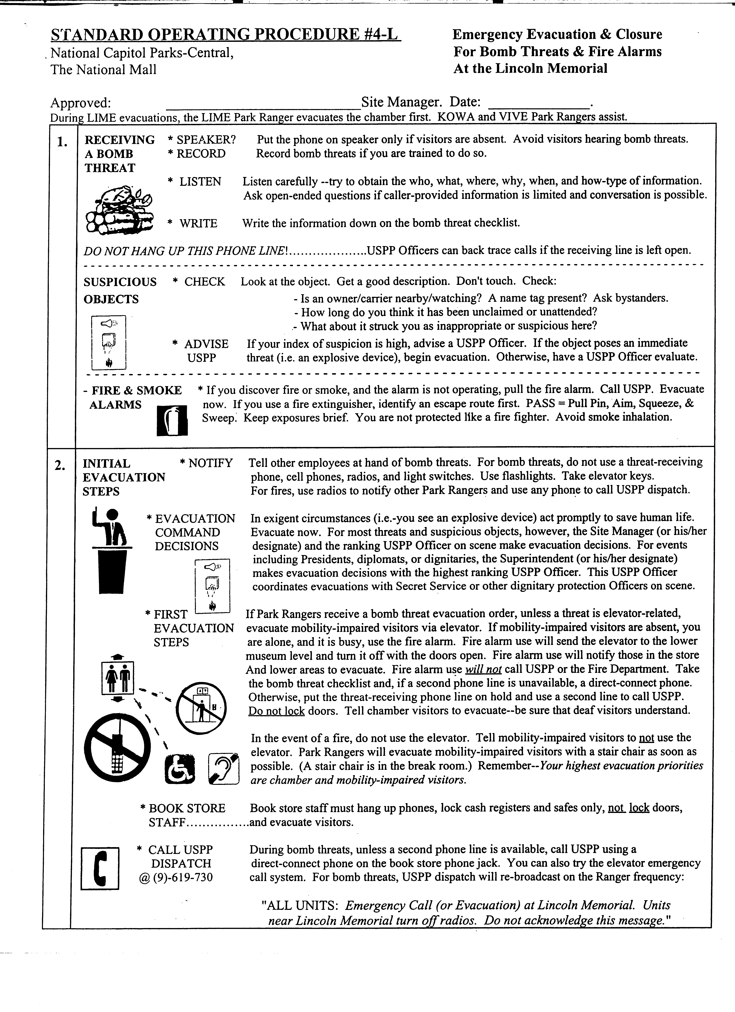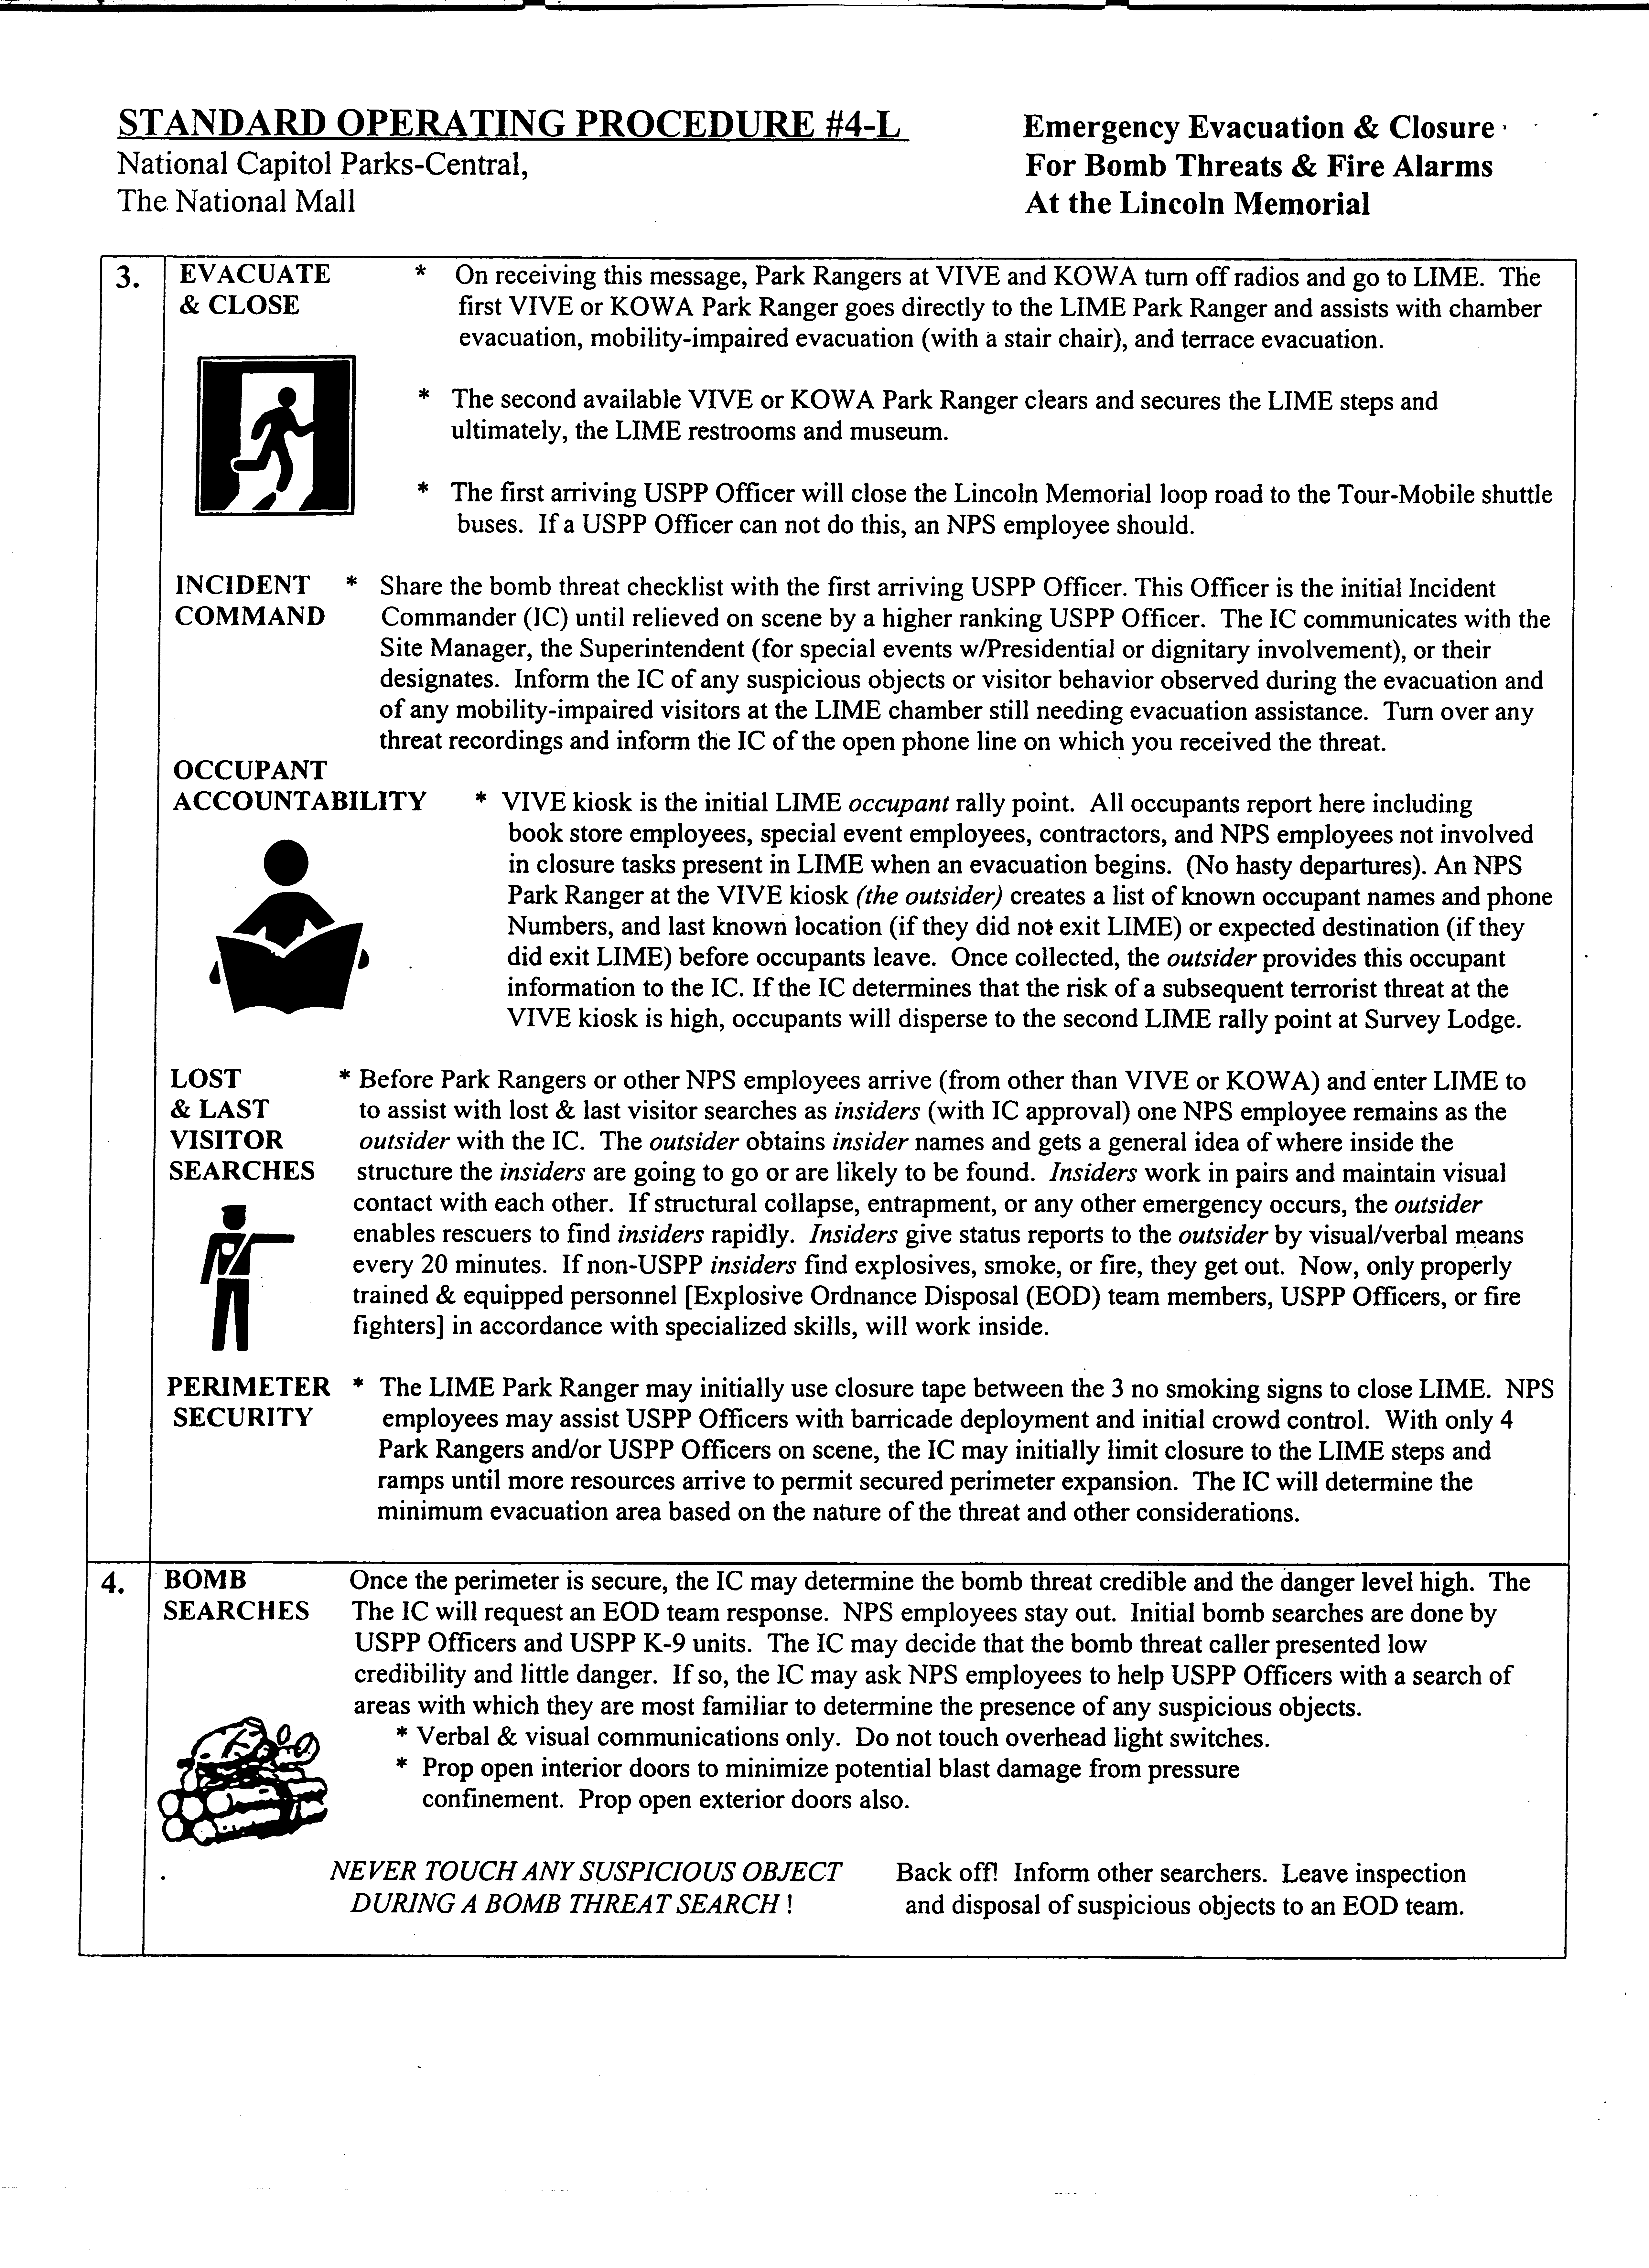
STANDARD OPERATING PROCEDURE #1-J: OPENING/ CLOSING PROCEDURE
JEFFERSON MEMORIAL

The National Mall
Visitor Services

Approved: Site Manager

Date: 10/9/95

Staff at the National Mall are responsible for opening/closing procedures at the Jefferson Memorial on a daily basis. Over the years staff have developed their own procedures based on experience at the site and the procedures have been handed down orally to new staff. This SOP has been written in order to effectively standardize opening/closing procedures at the Jefferson Memorial.

OPENING PROCEDURES

1. Enter the memorial from the lower lobby.

2. Go to the maintenance room located to the right of the bookstore entrance.

3. Turn on all light switches on the left as you enter the room. Then go to the breaker box located in the inner closet. Turn on all breaker circuits marked with an X and make sure all breakers are in the ON position. (#9, #11, and # 19). Before leaving make sure interior closet door is locked.

4. Visibly check the lower lobby and go to the chamber through the breakroom.

5. Turn on all light switches in the breakroom and any heaters if needed.

6. Continue on to the main chamber area and visually check the chamber for any problems.

7. Place the no food and drink signs on either side of the chamber entrance and set out the corner stone wayside.

8. Sign in and set up the log book for the day and set out all brochures at the information booth.

9. Unlock and open the doors to the elevator hallway and check the elevator to see if it is operating correctly.

* Check doors to see if they are locked - Door to the stairs next to the elevator,
door to the steps next to the gift shop, and the door to the steps in the lower lobby next to the elevator. The memorial should be open by 0800 hours.
CLOSING PROCEDURES

1. At approximately 2345 bring in all signs, including cornerstone wayside.

2. Lock both elevator hallway doors and turn out hallway lights.

3. Go down to the lower lobby (using the elevator), turnoff elevator lights, and make closing announcements to visitors.

4. Tell visitors in the lower lobby that they need to exit via the doorway (not the elevator).

5. Secure the main door to the lower lobby.

6. Check both restrooms for visitors.

- In the maintenance room, shut off the light switches and the breaker switches that are marked with X. Secure the inner room door before leaving.

- Go back upstairs through the breakroom.

9. Turn off lights (and heat) in breakroom.

10. At 2400 secure the ranger kiosk by turning off the heater (if on), lock windows, and lock door. Be sure all doors are secured before leaving the site. Make sure all visitor counts are completed for the day.

11. Bring radio back to supervisor at Survey.
STANDARD OPERATING PROCEDURE #2-J: REACTIVATING ELEVATOR
JEFFERSON MEMORIAL
AFTER AN ELEVATOR SHUTDOWN

Visitor Services
The National

Approved : (Site Manager)

Date:

In the event that the elevator at the Jefferson Memorial stops operating the following procedure should be completed:

PROCEDURE:

1) Check the elevator door tracks to see that nothing is stuck in them that would prohibit them from closing.

2) If nothing found in the tracks, proceed into the elevator and check to see that the "Emergency Stop" switch is not on.

3) If all of the above has been checked and found to be ok then proceed into the basement, of the memorial, and go into the elevator machine room (this requires a key from Supervisors). In this room you will find a large breaker switch, as you enter the room on your left. Turn this switch "OFF" then back "ON." this will reset the system.

If this does not correct the problem, contact the shift supervisor and inform them along with the actions you have taken. The supervisor will then contact the contractor to restore service.
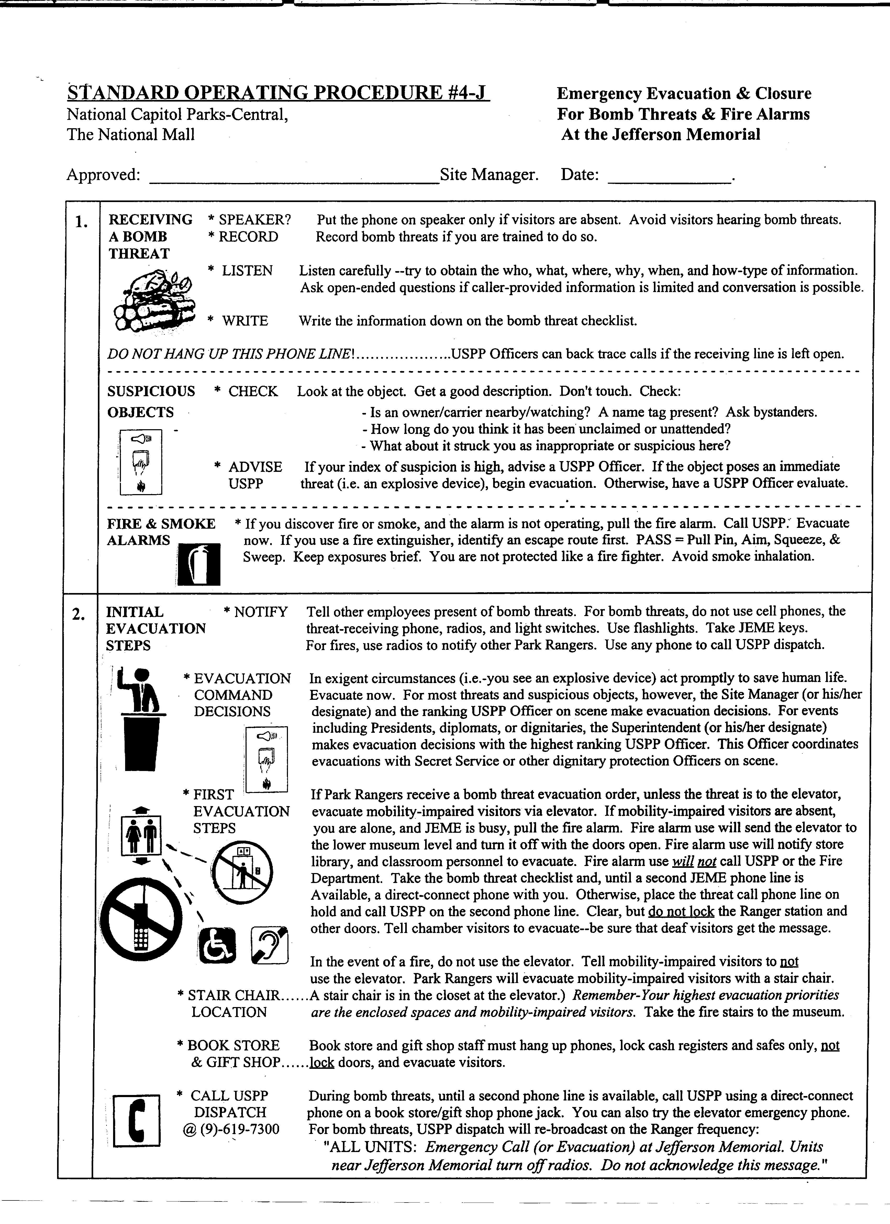
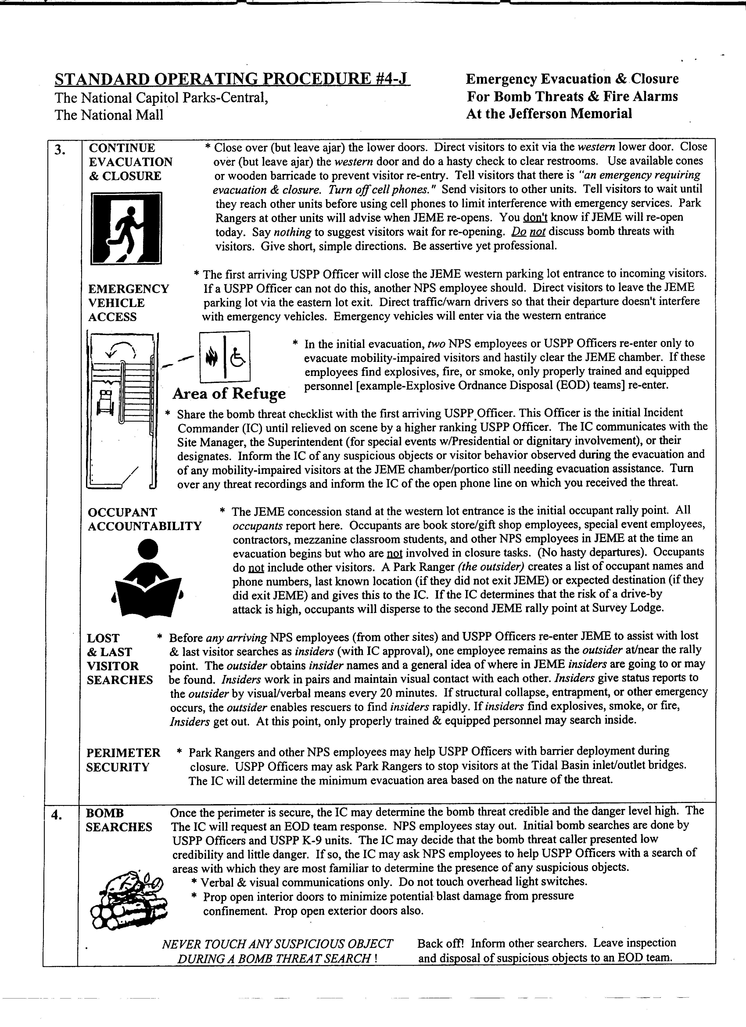
STANDARD OPERATING PROCEDURE #1-W EMERGENCY ELEVATOR
PROCEDURE FOR THE
WASHINGTON MONUMENT

The National Mall
Visitor Services

Approved: (original signed) (Site Manager)

Date: 8/15/95

When operation of the elevator of the Washington Monument is interrupted or stops, staff are responsible for dealing with the immediate situation. As such there is a 'need to know' standard procedure for dealing with such an emergency. 'Staff can only attempt to restart the elevator by using the key in the cab, or checking circuit breakers in the bunker of the monument. If the elevator will not restart, the elevator repair crew will respond quickly and assess the situation. They will restart the elevator as, soon as possible. NO ATTEMPT TO EVACUATE VISITORS WILL BE MADE UNTIL AUTHORIZED BY THE SUPERVISOR, AS NECESSARY. During the time that the elevator is stopped, it is the responsibility of the elevator operator to insure a calm and reassuring wait for visitors.

IF ELEVATOR STOPS RUNNING

1. Ranger on elevator will reassure the public that everything will be fine and that there is a procedure that will be followed to assure their safety. Explain that there is no danger of the elevator falling. There are at least 14 cables plus an automatic braking system (governor) that will hold the elevator in place.

2. Elevator operator will then call the lead ranger (426-6840) and inform them of the situation as well as the elevator's location with-in the shaft. This can be done by looking out the elevator window and determining the' floor number closest to the window. The elevator operator will also provide information as needed about the visitors in the elevator, such as disabled visitors or visitors with other obvious medical needs. 'After assessing the immediate situation, the lead ranger will then contact the shift supervisor (426-6841). The shift supervisor will make the appropriate calls to have the elevator repair operation respond. The lead ranger will troubleshoot the situation as per the shift supervisor’s instructions. *The only time that a fire and rescue team will be called is in case of a medical emergency that requires immediate assistance and evacuation from the elevator. Radio, and relay information about their situation. After this notification has been done, the shift supervisor will then make the appropriate calls to have an elevator repairman respond. * * The only time a fire and rescue team will be called is in case of medical emergency that requires immediate evacuation from the elevator.

3. Once all of the above has been done, the elevator operator will remain in telephone contact with the “lead” and will continue to reassure visitors what is being done to correct the problem. The elevator operator should do their best to keep a positive and upbeat mood among visitors on the elevator. At no time will the elevator operator attempt to open any of the elevator doors to evacuate the elevator. They are to remain inside the elevator and wait for instructions from the lead or shift supervisor.

DUTIES OF THE LEAD RANGER DURING THIS SCENARIO ARE TO:

1. NOTIFY THE SHIFT SUPERVISOR (426-6841) by telephone or radio, and relay all information concerning the situation. Explain what the elevator was doing just prior to the problem. The shift supervisor will need to know this to provide an assessment of the situation to the elevator repair service.

2. CALL THE 500 FOOT LEVEL: advise the ranger at that location of the situation. If it is deemed necessary to walk the visitors down the steps, that decision will be made by the shift supervisor. The ranger at the 500 foot level will calmly advise visitors of the problem and assure them that we are working to correct the situation. The ranger will do a visual survey of visitors at the 500 and 490 foot levels to determine if there are any disabled visitors or visitors with medical problems that may require assistance. They will report this information to the lead ranger.

3. TROUBLE SHOOT THE PROBLEM: go into the ranger room and check the gate monitoring readout to see if any of the landing gates are open. If the readout shows a number other than '0' there is a gate open at the landing indicated. A ranger will have to walk up to the floor indicated by the readout and physically close the gate. This should correct the problem and the elevator should operate.

If the readout shows all gates closed, check in the power room, located in the bunker, to see if the main power switch has been turned off. This switch is located in the middle of the panel between the two mains for the light vaults. If this switch is in the upright position, the power is still on and this is not the problem. At all times keep the shift supervisor appraised of the troubleshooting investigation.

4. SEND TWO RANGERS UP THE.STAIRS: one will be sent to the location of the elevator and another will go to the 500 foot level to assist with the potential evacuation of visitors in that area. * Remember, no evacuation of visitors from the elevator will take place unless it has been deemed necessary by a supervisor and it is at a landing.
m
5. During all evacuations, the lead ranger will keep the shift supervisor informed of all actions being taken. If the monument has to be closed and the line dismissed, the shift supervisor will make that decision and will notify the lead as to: what actions to take.
EVACUATION PROCEDURES:

In the event that the elevator cannot be reactivated by the elevator repair service and all avenues have been explored, the following will be done to safely evacuate visitors from the elevator and the 500 foot level.

1. If the elevator has stopped at one of the landings or is considered to be at a safe distance to the landing, the ranger that has walked up the steps to the elevator will do the following:

* Wait for the shift supervisor to arrive at the landing and to order an evacuation.

* Open the landing gate (with a M-20 key) nearest to the elevator and step out onto the landing platform. Advise the elevator operator which door is to be opened.

* Elevator operator will then advise the visitors on the elevator to stand away from the door to be opened. They will then proceed to open the door with the control panel.

To open a door, remove the elevator key from the main switch on the control panel and place it in the lower door key hole (depending on which door is to be opened) located at the bottom of the control panel on the left and right, and turn the key. You will hear a "click" at the door that has been activated. The rear door, next to the elevator operator, will be the only door that will open automatically when the ^{1t}RDO" button is pushed. The front door, after the '¹FDO¹¹ button is pushed, will have to be opened by hand by the ranger standing outside the elevator on the platform.

* Once a door has been opened, the 3 rangers will then assist the visitors, one by one, out of the elevator and on to the stair landing. DO NOT RUSH THIS OPERATION, TAKE YOUR TIME. IT WILL SAVE A LIFE.

* Once all the visitors are out of the elevator, two of the rangers will walk them down the steps. The third ranger will remain with the elevator. If there is a wheelchair user or disabled person on the elevator that cannot easily be evacuated, have them remain with the third ranger. Do not attempt to get them off the elevator. A fire rescue team will be called to evacuate them.

* If the elevator is unable to be restarted by the elevator repair service and it has stopped at what is considered an unsafe distance from a landing, a fire and rescue team will be called to evacuate visitors. The elevator operator will let everyone know what is taking place and do their best to maintain a calm situation on the elevator. They should remain in the elevator with the doors closed until ordered to open them by the shift supervisor.

- The shift supervisor will notify the lead to walk the visitors down the steps from the 500 and 490 foot levels. After the ranger assigned to walk to that level has arrived, the ranger will begin leading people down the steps. If there is a disabled person or a person who cannot walk steps, one ranger will remain with them until the elevator becomes operational or an emergency evacuation is ordered.
STANDARD OPERATING PROCEDURE #2W EMERGENCY CLOSURE:
WASHINGTON MONUMENT
FOR LIGHTNING STORMS

The National Mall
Visitor Services

Approved: (original signed) (Site Manager)

Date: 9/20/95

Closing the Washington Monument during an approaching thunder and lightning storms is an important operational aspect in providing for the safety of visitors to the site. When severe weather does approach, the procedures listed below are to be followed.

PROCEDURES:

- When threatening weather approaches:

a. Notify Supervisor, by radio or phone.

b. Notify Ranger at 500 ft. and in Elevator along with Parks and History Bookstore person.

c. Decrease elevator loads to half. This will result in cutting down the number of people at the top and allow visitors to be evacuated in one trip if necessary.

d. Monitor storm progress and report this information to the shift Supervisor.

- The shift Supervisor should follow these procedures:

- Call NORA Weather Radio Station at (703) 260-0107, 7:00 a.m-5:00 p.m. or (703) 260-0106 for 24 hour reports.

* Identify yourself as with the NPS, Washington Monument.
* Inquire about lightning detection with the approaching storm and its direction.

- Monitor NORA Weather Radio on Base Station or Office weather radio.

c. Monitor outside weather conditions and make decision to close monument when appropriate.

3) To Close the Monument.

a. Supervisor will notify monument crew to close, by radio or phone.

b. Supervisor will the notify .the Superintendent's Office - 485-9880,
and the office of Public Affairs - 619-7222

c. Supervisor will then proceed to the site to assist in its closures.

d. Rangers will inform public, in waiting room and those waiting in line, that the monument is closed do to the approaching storm and to move to the bottom of the hill.

* At this same time the ranger at the 500 ft. level and elevator operator will be informed of the closing.

* Ranger at 500 ft. level will begin moving visitors down to the 490 ft. level to take the elevator down. This should be done in a cool and calm manner.

4) Once all the visitors have been evacuated from the site, the site will be locked and any remaining visitor should be encouraged to move off the hill. Once the hill is cleared, the Supervisor will transport the monument crew down to Survey.

5) A ranger from the monument's crew or one of the shift supervisors will then take a vehicle back up to the monument and patrol the circle to keep visitors away during the storm.

6) Supervisor and monument staff will continue to monitor the storm and will reopen the monument when the storm has passed. Supervisor will make the call to reopen.
STANDARD OPERATING PROCEDURE #3-W EMERGENCY CLOSURE:
WASHINGTON MONUMENT
HIGH WINDS

The National Mall
Visitor Services

Approved: (original signed) (Site Manager)

Date: 9/20/95

CL0SlNG WASHlNGT0N MONUMENT DURING HIGH WINDS

When wind gusts at the base of the Washington Monument become severe following procedures should be followed.

1) Place a call to National Airport's Weather Office at (703) 260-0106. You will get a recording that will give you the current wind speed.

2) If wind speeds and guest exceed 30 MPH, notify the Shift Supervisor of the conditions and wind speed. Supervisor will the make the decision to close the site or to remain open.

3) If the decision is made to close the site.

* The shift Supervisor will notify the Superintendent's Office 485-9880,
and the office of Public Affairs 619-7222 to inform them of the closing.

* Visitors waiting in line will be informed that the monument is being
closed for high winds and encouraged to move off the hill.

* Rangers working the elevator and 500 foot level will be notified of the closing.

* Visitors in the waiting room will be allowed to continue their visit. Visitors at the 500 and 490ft levels will be allowed to remain and will be allowed to leave at their leisure and will NOT be encouraged to leave as is done during an approaching lighting storm.

* Ranger Staff will display the, "Monument Temporary Closed" on the front gate of the site.

4) Once the monument has been closed the ranger staff will do the following:

* Remain on site to advise visitors to stay off the monument hill do to the winds.

* Staff the 15th Street Kiosk and provide information and visitor services.

* Supervisor may assign rangers to work on projects and research.

* If winds persist, some rangers may be reassigned to work another site as needed, for the duration of the high winds situation.
STANDARD OPERATING PROCEDURE #4-W LAST GROUP
PROCEDURE
WASHINGTON MONUMENT

The National Mall
Visitor Services

Approved: (original signed) (Site Manager)

Date: 9/20/95

PROCEDURE

The following procedure should be adhered to when letting the last group of the day in to the Washington Monument. Ideally, the last group should be sent up on the elevator at either 4:45 PM (Day Shift - Winter), or 11:45 PM (Night Shift - Summer). The last group sent to the top of the Washington Monument should be allowed at least 15 minutes time at the top of the monument. Generally they will not take the full time at the end of the day, however, it may occasionally mean that staff will not get out right at 5:00 PM or midnight.

Visitors should not be rushed due to a failure on our part to correctly estimate the length of the line, or because it is near the end of the shift. After waiting in line for an extended period of time, visitors should be allowed to enjoy what they waited for.

Adhering to this procedure will not generally create a problem for staff. On the rare occasion that staff has to remain late to accommodate visitors, comp time may be granted.
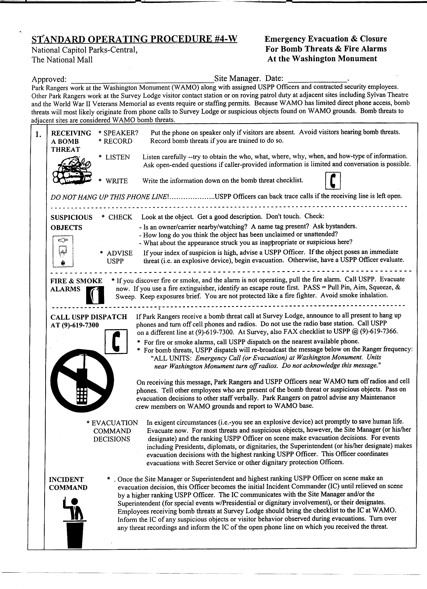
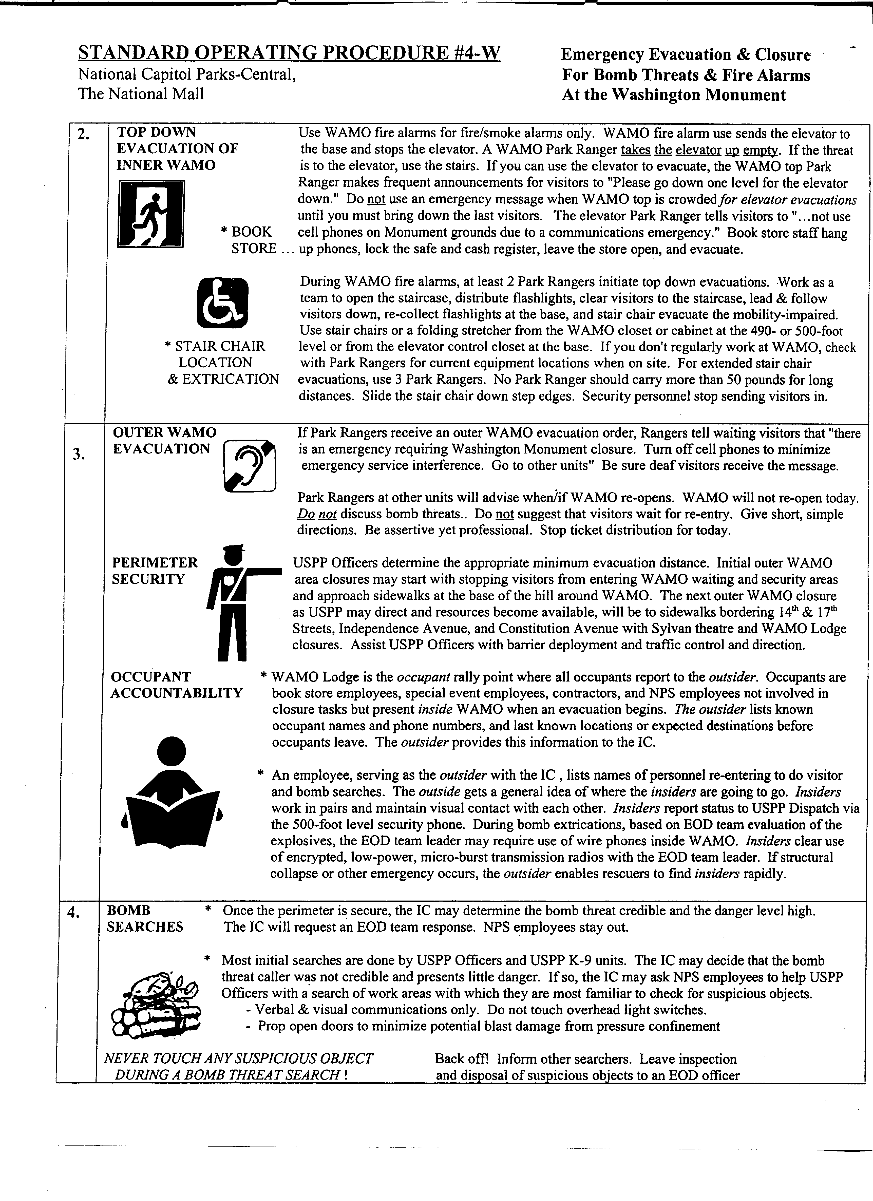
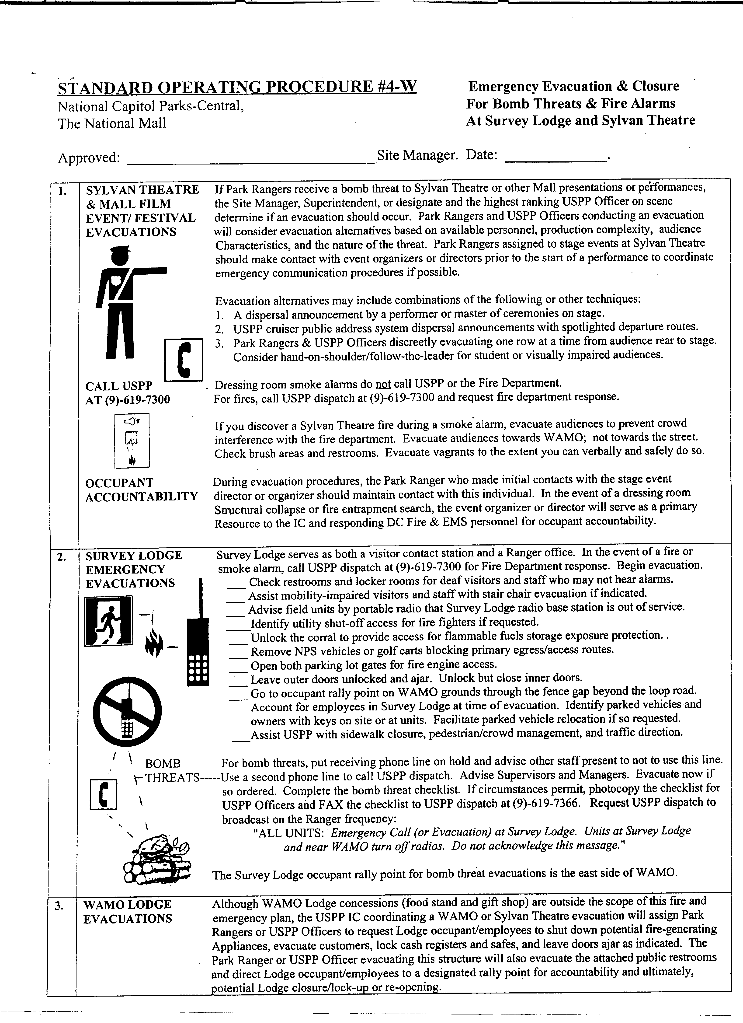
STANDARD OPERATING PROCEDURE #1-VVM OPENING/ CLOSING
PROCEDURES
VIETNAM VETERANS
MEMORIAL

The National Mall
Visitor Services

Approved: (original signed) (Site Manager)

Date: 3/12/96

Staff at the National Mall are responsible for opening and closing procedures at the Vietnam Veterans Memorial on a daily basis. Over the years staff have developed their own procedures based on experience at the site and the procedures have been handed down orally to new staff. This SOP has been written in order to effectively standardize opening and closing procedures at the Vietnam Veterans Memorial.

OPENING PROCEDURES:

1. Turn off Alarm and enter the Kiosk.

a. press upper left-hand key ^, under the word “DISARM"

b. enter code₁ by pressing number buttons

c. system will show "DISARMED"

2. Turn computer screen and printer on and run a check to see if it works.

3. Sign in and set up the log book for the day.

4. Put brochure box(s) out on the ledge in front of the windows.

5. Put ladder out behind the Kiosk.

6. Visually inspect the kiosk and the general area, make sure there are enough maps and brochures for the day.

7. Visually inspect the Wall and clean any spots off following the SOP for cleaning the Wall.

CLOSING PROCEDURES:

* Closing procedure described below should begin at approximately 2350 hours.

1. Bring brochure box(s) into the kiosk.

2. Close and lock all windows

3. Turn computer screen and printer off (CPU remains on).

4. Sign out in the log book located on the counter and make sure all visitor counts are completed.

5. Turn out all front lights with switches located on the wall near the thermostat.

6. Bring ladder into the kiosk.

7. Turn off remaining lights with switches located at the right of the back door.

8. Setting the alarm [Only one person should remain in the kiosk and the door must. be securely closed].

9. Procedure for setting the alarm:

a. press upper left-hand key ^
b. message will appear "INTERIOR ON TO-SET ALARM, ENTER CODE."
c. enter code slowly, (alarm will sound briefly).
d. exit the back door and make sure the door is locked before leaving the site.
STANDARD OPERATING PROCEDURE #4VVM CLEANING THE
VIETNAM VETERANS MEMORIAL WALL

The National Mall
Visitor Services

Approved: ___(original signed)________________________( Site Manager)

Date: 3/12/96

Occasionally the Wall at the Vietnam Veterans Memorial is marred by minor spots such as bird droppings or hand oils. The ranger staff has been granted permission to clean the "Wall¹¹ of these small spots. A five gallon bottle of a cleaner called "Igepel” has been provided for this cleaning and is located in the VVM Kiosk.

PROCEDURE FOR CLEANING THE WALL

1. Spray the spot and the surrounding area with plenty of clear water and try to clean with water only first.

2. If the water does not remove the spot, spray the effected area thoroughly, with the Igepel cleaner.

3. Wipe the effective area gently with a clean soft rag and then rinse with clean water.

4. Never attempt to wipe off a spot, especially bird droppings, without using water first.

** The Wall should be checked daily for spots and should be cleaned as needed. Each shift, at VVM, are responsible for checking the Wall and spot cleaning as necessary.
Memorandum

To: All Staff, The National Mall

From: Site Managers, The National Mall

Subject: FDR Memorial Visitor Do's and Don'ts

Now that the opening of the FDR Memorial has finally arrived, the issue of what visitors can and cannot do, or what media can or cannot do is paramount. The following is a general procedure to follow.

- Climbing on the Walls and Waterfalls: Not Allowed.

2. Wading: Signs are posted for no wading. We will allow visitors to dangle feet in
the water and walk/wade. Activities that are dangerous or unacceptable for the area will not be allowed. For example, walking (wading) in the pools is fine, running and splashing is not. You are going to have to use your judgment in this area. If an activity is a threat to the safety of the visitor, other visitors, or the resource, it will not be allowed. Keep in mind that this memorial is different than all the others, it is meant to be interactive, but not so much as to allow swimming, excessive splashing, running, or general horseplay in the pools. Children wading in the pools must be accompanied by an adult.

- Food and Drink: Not Allowed. Signs are posted as such.

- Bicycles: Not Allowed. Signs are posted as such.

- Skateboarding, Roller Skating or In-Line Skating: Not Allowed. Signs are
posted as such.

- Smoking: Not Allowed. Signs are posted as such.

- Running: Not Allowed: Sign posted as such

8. Pets on a Leash: Allowed.

The area where we will limit activities of visitors, will be that which is defined by the outside edge of the actual stone walkways of the Memorial; the area from the entrance wall at the northwest end through the Memorial to just past the rest rooms on the southeast end, and only within the stone walkway confines of the Memorial running from the southwest edge of the berm to the edge of the walkways on the northeast sideTidal Basin side). Grassy areas within the Memorial and the berm are also considered in the defined area. There will be signs posted on the berm facing the ballfields that say "Danger Area Closed Keep Out". Within the paved area media can do B-Roll, hand-held cameras and with tripods (rubber tipped) only; no cabling and no live shot set-ups. No food, drink, or picnics can be held in that area. The grassy areas just off the edge of the walkways along the Tidal Basin are areas where picnics can be held, and where activities are less restricted. Interviews may be conducted in this area as long as they do not interfere with the general public's use and enjoyment of the Memorial. The area outlined in red on the diagram attached, is the area where we will limit activities.

Memorandum

To: Division Chiefs, Branch Chiefs, Site Mangers, and Supervisors

From: Superintendent, National Capital Parks-Central

Subject: Standard Operating Procedures During Heat Conditions

We are providing you with a copy of the standard operating procedures for work efforts during heat conditions for National Capital Parks-Central. It is important that all supervisors adhere to
these procedures to insure the health and well-being of our employees.

The Safety Manager, Joan Whiting, will advise the Division Chiefs when Code II and III conditions exist, during regular working hours Monday through Friday. They in turn are responsible for notifying the field. During weekends, holidays, and in the absence of the safety manager, all managers and supervisors are responsible for reviewing the attached chart and ensuring SOPs are implemented on those days when Code II and III are in effect.

For further information, contact Safety Manager, Joan Whiting, on (202) 485-9880.

Attachment
Standard Operating Procedures For National Capital Parks-Central Employees
During Extreme Heat Conditions

NCP-Central will use the National Oceanic and Atmospheric Administration (NOAA) apparent temperature index (combination of temperature and humidity) to determine extreme heat conditions. Apparent temperatures above 80 will be categorized as follows:

Code I - Apparent temperature 80-89

Code II- Apparent temperature 90-109

Code III - Apparent temperature 110+ or Air Quality Index Code Red

Outdoor activities will continue as usual. Supervisors will monitor employees, breaks and fluid intake.

Strenuous outdoor activities will be modified. Regular activities will be conducted reducing employees' exposure to sun. Breaks will be extended and supervisors will monitor employees and their fluid intake.

Strenuous outdoor activities will be postponed except for emergencies. Regular scheduling of activities will be modified and conducted reducing employees' exposure to the sun. Breaks will be extended and supervisors will monitor employees and their fluid intake.

Supervisors will ensure that each crew be supplied with fresh drinking water throughout the day.

Supervisors shall take in consideration employees who are taking medication and/or may have special problems.

The Safety manager will monitor apparent temperatures and notify the Superintendent/ Deputy Superintendent and all Division Chiefs of Code II and III conditions.

Sources for temperature and humidity readings:

1. The National Oceanic and Atmospheric Administration (703-260-0307)

2. The Washington Council of Governments (202-962-3299)

